INVESTMENT THEORY PROJECT
APPLICATION OF MACHINE LEARNING FOR STOCK MARKET DECISION AND PORTFOLIO CONSTRUCTION

MANISH SHARMA

INTRODUCTION
The objective of this project is to analyse the risk and return characteristics of selected securities, apply machine learning techniques for predicting stock prices, evaluate a machine-learning-based trading strategy through backtesting, and construct portfolios that balance risk and return.
For the analysis, ten securities from different sectors of the US equity market were selected: Apple Inc. (AAPL), Microsoft Corporation (MSFT), JPMorgan Chase & Co. (JPM), Eli Lilly and Company (LLY), Target Corporation (TGT), A. O. Smith Corporation (AOS), Northern Oil and Gas (NOG), Portland General Electric (POR), FedEx Corporation (FDX), and PayPal Holdings (PYPL).
Daily price data were analysed for the period from January 2023 to January 2026. The dataset contains 752 observations for each security. The analysis covers three broad areas. First, the historical risk-return characteristics of the securities are examined using measures such as total return, volatility, Sharpe ratio, maximum drawdown, beta and Value at Risk. Second, machine learning models, namely XGBoost and LSTM, are used to predict next-day closing prices for JPM and PYPL. Finally, the analysis evaluates trading and portfolio strategies through backtesting and compares an equal-weight portfolio with an optimized portfolio.
The purpose of the analysis is not merely to identify securities with high returns, but to determine whether those returns are achieved efficiently relative to the amount of risk undertaken. The project therefore considers both return generation and risk management, which are central to investment decision-making.

DATA AND METHODOLOGY
The analysis uses daily closing-price data for the ten selected securities. Daily returns are calculated from changes in closing prices. The major market-based measures used in the analysis are total return, annualized volatility, Sharpe ratio, maximum drawdown, beta and daily Value at Risk at the 95% confidence level.
A risk-free rate of 4% per annum is assumed for the calculation of the Sharpe ratio. Annualized volatility is calculated using 252 trading days, which represents the conventional number of trading days in a year.
Two machine learning approaches are considered:
- XGBoost, a tree-based gradient boosting algorithm.
- LSTM, a recurrent neural network designed to learn patterns from sequential or time-series data.
The predictive performance of the two models is evaluated using:
- Root Mean Squared Error (RMSE)
- Mean Absolute Percentage Error (MAPE)
For both measures, lower values indicate better forecasting performance.

QUESTION 1(i): BRIEF OVERVIEW AND COMPARISON OF THE SELECTED SECURITIES
The selected securities exhibit substantial differences in terms of return, volatility, market sensitivity and fundamental characteristics. Therefore, simply comparing their total returns would not provide a complete picture of their investment attractiveness.
Key Risk-Return Statistics
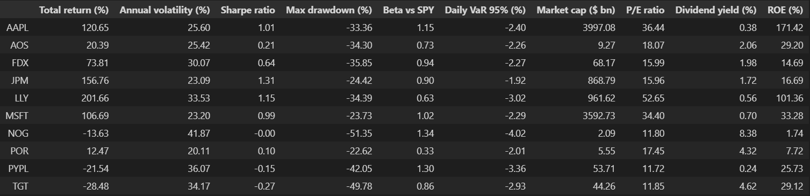
Total Return Analysis
Total return measures the overall change in the value of an investment over the sample period. It is one of the most direct measures of investment performance.
Among the ten securities, LLY was the best-performing security, recording a total return of 201.66%. This means that an investment made at the beginning of the period would have more than tripled in value, ignoring any separate consideration of transaction costs.
JPM was the second-best performer, with a total return of 156.76%. AAPL also performed strongly, generating a return of 120.65%, while MSFT generated 106.69%.
FDX generated a positive return of 73.81%, while AOS generated a relatively modest positive return of 20.39%. POR recorded a positive return of 12.47%.
In contrast, three securities generated negative cumulative returns. TGT recorded the weakest performance at −28.48%, followed by PYPL at −21.54% and NOG at −13.63%.
Therefore, based purely on cumulative return, the ranking is dominated by LLY, JPM, AAPL and MSFT, whereas TGT, PYPL and NOG were the weakest performers.
However, total return alone does not provide information about the risk undertaken to achieve that return. For this reason, the volatility and Sharpe ratio are considered next.

Annualized Volatility
Volatility measures the degree of fluctuation in a security's returns. Higher volatility indicates greater uncertainty and therefore generally greater risk.
NOG recorded the highest annualized volatility at 41.87%, making it the most volatile security in the sample. PYPL followed with 36.07%, while TGT recorded 34.17%. LLY also had relatively high volatility of 33.53%.
At the other end of the spectrum, POR had the lowest annualized volatility at 20.11%. JPM and MSFT had relatively moderate volatility levels of 23.09% and 23.20%, respectively.
The comparison between LLY and JPM is particularly interesting. LLY generated a higher total return than JPM, but its volatility was also substantially higher. Therefore, an investor must consider whether the additional return from LLY sufficiently compensates for its additional risk.
This is why risk-adjusted measures such as the Sharpe ratio are important.

Sharpe Ratio and Risk-Adjusted Performance
The Sharpe ratio measures the amount of excess return generated per unit of total risk. A higher Sharpe ratio generally indicates better risk-adjusted performance.
The results show that JPM recorded the highest Sharpe ratio of 1.31. This is particularly significant because JPM did not have the highest total return; instead, its high Sharpe ratio resulted from the combination of strong returns and comparatively moderate volatility.
LLY recorded the second-highest Sharpe ratio of 1.15, followed by AAPL at 1.01 and MSFT at 0.99.
Thus, JPM appears particularly attractive when performance is evaluated relative to the amount of volatility undertaken. LLY generated the highest absolute return, but JPM generated the highest return relative to its risk according to the Sharpe ratio.
AOS and FDX recorded Sharpe ratios of 0.21 and 0.64, respectively, indicating positive but comparatively weaker risk-adjusted performance.
POR had a Sharpe ratio of 0.10, indicating that although it generated a positive return, its excess return relative to risk was relatively small.
NOG had a Sharpe ratio approximately equal to zero, while PYPL and TGT recorded negative Sharpe ratios of −0.15 and −0.27, respectively. A negative Sharpe ratio indicates that the investment did not provide sufficient excess return relative to its volatility over the sample period.
Therefore, based on risk-adjusted performance, JPM emerges as the strongest security in the sample.

Maximum Drawdown
Maximum drawdown measures the largest percentage decline in the value of an investment from a previous peak to the subsequent trough. It is an important measure of downside risk because it indicates the severity of the worst historical decline.
NOG recorded the largest maximum drawdown at −51.35%. This means that at some point during the sample period, its value declined by approximately 51% from a previous peak before recovering.
TGT also experienced a very large maximum drawdown of −49.78%, while PYPL recorded −42.05%.
LLY, despite its strong overall performance, experienced a maximum drawdown of −34.39%, while AAPL and AOS recorded drawdowns of −33.36% and −34.30%, respectively.
The smallest maximum drawdown was recorded by POR at −22.62%, followed by MSFT at −23.73% and JPM at −24.42%.
This indicates that JPM and MSFT not only generated strong returns but also experienced comparatively smaller peak-to-trough declines. This strengthens their attractiveness from a risk-management perspective.
It is important to note that maximum drawdown does not mean that the security ended the period with that percentage loss. It represents the largest decline from a historical peak to a subsequent trough during the period.

Beta and Market Sensitivity
Beta measures the sensitivity of a security's return to movements in the broader market. In this analysis, SPY is used as the market reference.
A beta greater than one indicates that the security tends to be more sensitive to market movements, while a beta below one indicates lower sensitivity.
NOG recorded the highest beta at 1.34, followed by PYPL at 1.30 and AAPL at 1.15. These securities therefore showed relatively greater sensitivity to movements in the market.
MSFT had a beta of 1.02, which is approximately equal to one, indicating market-like sensitivity.
JPM and FDX had betas of 0.90 and 0.94, respectively, indicating slightly lower market sensitivity.
The lowest beta was recorded by POR at 0.33, followed by LLY at 0.63 and AOS at 0.73. These securities therefore showed lower sensitivity to movements in SPY.
An interesting case is LLY, which had relatively high total volatility of 33.53% but a beta of only 0.63. This means that LLY's overall price fluctuations were substantial, but its returns were comparatively less sensitive to movements in SPY. Therefore, LLY could potentially contribute diversification benefits when combined with securities that have higher market sensitivity.

Daily Value at Risk at 95%
Value at Risk, or VaR, provides an estimate of potential downside exposure at a specified confidence level.
At the 95% level, the daily VaR indicates the lower-tail behaviour of daily returns. A more negative value indicates greater downside exposure.
NOG recorded the most negative daily VaR of −4.02%. Thus, according to this historical VaR measure, approximately the worst 5% of daily return observations were at or below a loss of 4.02%.
PYPL had a VaR of −3.36%, while LLY recorded −3.02% and TGT −2.93%.
In contrast, JPM recorded the least negative VaR of −1.92%, followed by POR at −2.01%.
Therefore, JPM had the lowest estimated extreme daily downside among the securities according to this particular VaR measure, while NOG had the highest.

Fundamental Characteristics
The fundamental characteristics provide additional information beyond historical market performance.
Market Capitalization
AAPL had the largest market capitalization at approximately $3,997.08 billion, followed by MSFT at approximately $3,592.73 billion.
LLY and JPM had market capitalizations of approximately $961.62 billion and $868.79 billion, respectively.
NOG had the smallest market capitalization at approximately $2.09 billion.
P/E Ratio
LLY had the highest P/E ratio at 52.65, followed by AAPL at 36.44 and MSFT at 34.40.
A higher P/E ratio indicates that investors are paying a higher price relative to the company's current earnings. However, the P/E ratio should not be interpreted in isolation because differences in expected growth and industry characteristics can influence valuation.
NOG, PYPL and TGT had relatively lower P/E ratios of 11.80, 11.72 and 11.85, respectively.
Dividend Yield
NOG had the highest dividend yield at 8.38%, followed by TGT at 4.62% and POR at 4.32%.
At the other end, PYPL had a dividend yield of 0.24%, while AAPL and LLY had yields of 0.38% and 0.56%, respectively.
Return on Equity
ROE measures the return generated relative to shareholders' equity.
AAPL recorded an exceptionally high ROE of 171.42%, followed by LLY at 101.36%.
MSFT recorded an ROE of 33.28%, while AOS and TGT recorded 29.20% and 29.12%, respectively.
NOG recorded the lowest ROE at 1.74%.
These figures indicate substantial differences in profitability and capital efficiency across the selected securities.

Overall Assessment of the Securities
The results indicate that no single security dominates every risk and return measure.
LLY was the strongest performer in terms of total return, with 201.66%, but it also had relatively high volatility of 33.53% and a maximum drawdown of 34.39%.
JPM provides perhaps the most balanced risk-return profile. It generated a very high return of 156.76%, had relatively low volatility of 23.09%, the highest Sharpe ratio of 1.31, a relatively low maximum drawdown of 24.42% and a beta below one.
AAPL and MSFT also showed strong performance with positive risk-adjusted returns and comparatively moderate volatility.
In contrast, NOG appears considerably more risky because it combined negative total return, the highest volatility, the largest drawdown, the highest beta and the most negative VaR.
PYPL and TGT also exhibited weak performance, with negative total returns, relatively high volatility and negative Sharpe ratios.
POR had defensive characteristics due to its low volatility and low beta, although its total return and Sharpe ratio were relatively modest.
Therefore, an investor seeking high absolute returns might favour securities such as LLY, while an investor focusing on risk-adjusted performance might find JPM particularly attractive. The portfolio analysis in Question 2 is important because combining securities can potentially provide a better overall risk-return profile than holding individual securities alone.

QUESTION 1(ii): COMPARISON OF DAILY RETURNS
Daily Return Behaviour
Daily returns were calculated for all ten securities for the period January 2023 to January 2026.
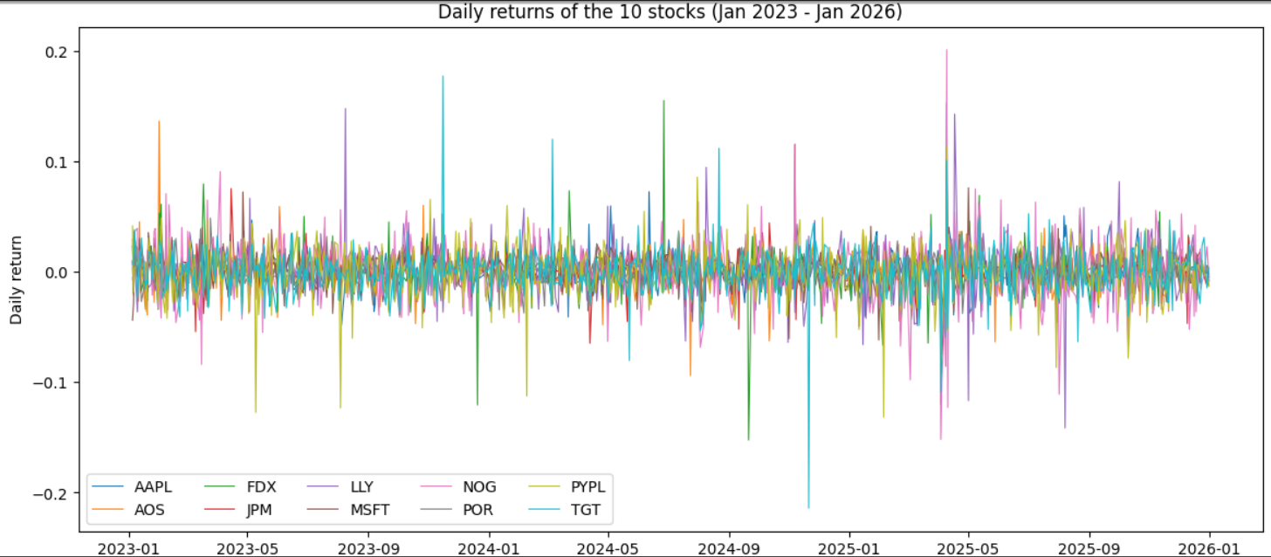
The graph shows that the daily returns of all ten securities fluctuate around zero. Most daily observations are concentrated within a relatively narrow range, but there are occasional large positive and negative spikes.
This behaviour is consistent with the nature of financial asset returns, where most days exhibit relatively small changes but certain days can produce unusually large movements.
The securities differ significantly in their daily volatility.
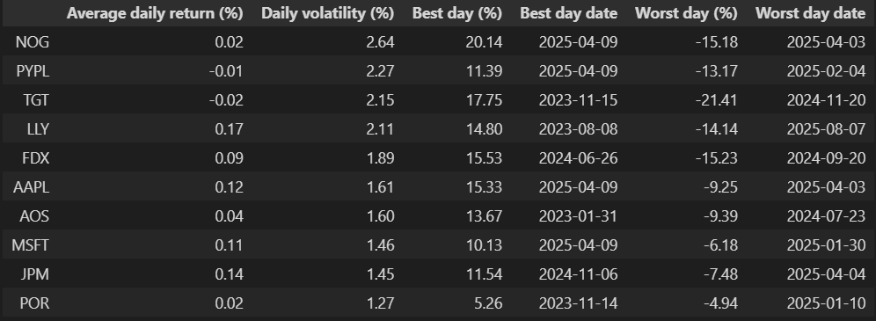
LLY recorded the highest average daily return of 0.17%, followed by JPM at 0.14%, AAPL at 0.12% and MSFT at 0.11%.
At the same time, NOG had the highest daily volatility at 2.64%, indicating substantial day-to-day fluctuations.
POR had the lowest daily volatility at 1.27%, indicating comparatively stable daily returns.
PYPL and TGT recorded negative average daily returns of −0.01% and −0.02%, respectively.
The largest positive daily return in the summary was recorded by NOG at 20.14% on 9 April 2025, whereas the largest negative daily return was recorded by TGT at −21.41% on 20 November 2024.
These extreme observations highlight the importance of considering downside risk rather than relying only on average returns.

GROWTH OF $1 INVESTED
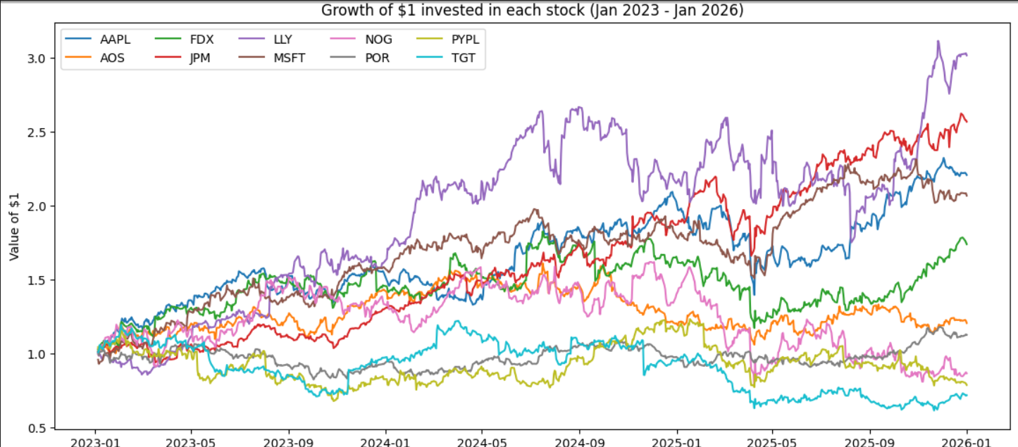
The growth-of-$1 graph shows how an initial investment of one dollar would have changed in value over the sample period if it had been invested in each individual security.
The graph shows considerable divergence between the securities.
LLY generated the strongest cumulative growth. The value of the initial $1 investment increased to approximately $3 by the end of the period.
JPM also showed strong cumulative growth and ended at approximately $2.6. AAPL and MSFT also generated substantial growth, ending at approximately $2.2 and $2.0, respectively.
In contrast, TGT and PYPL ended below the initial value of $1, consistent with their negative total returns. NOG also ended below its initial value despite experiencing some very large positive daily movements.
The graph therefore provides a visual confirmation of the total-return analysis.
The important investment implication is that high short-term volatility does not necessarily translate into high long-term returns. NOG, for example, experienced the highest volatility but generated a negative cumulative return, whereas JPM achieved strong cumulative growth with substantially lower volatility.

CORRELATION ANALYSIS
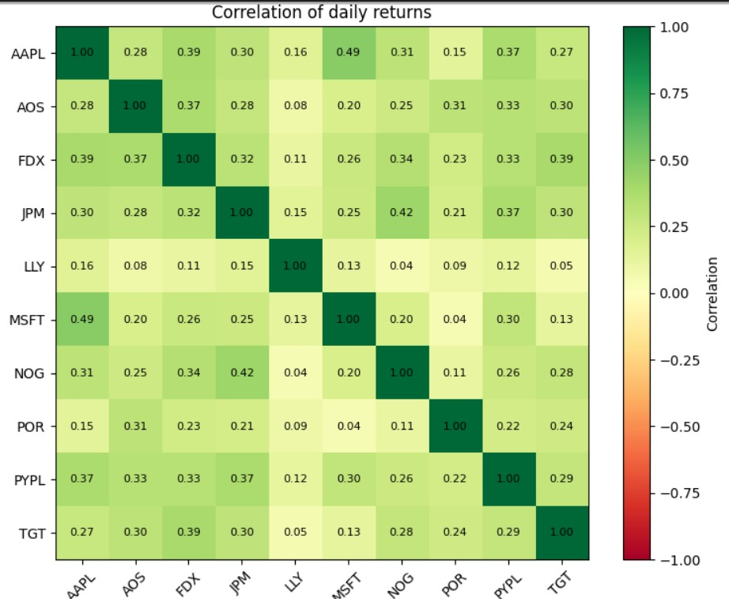
Correlation measures the degree to which the returns of two securities move together. A correlation close to +1 indicates strong positive co-movement, while a correlation close to zero indicates a weak linear relationship.
The correlation matrix shows that the securities are generally positively correlated, but the strength of the relationship varies considerably.
The highest correlation is between AAPL and MSFT at 0.49. This indicates a moderate positive relationship between the daily returns of the two securities.
Other relatively high correlations include:
- JPM and NOG: 0.42
- AAPL and FDX: 0.39
- FDX and TGT: 0.39
- JPM and PYPL: 0.37
- AAPL and PYPL: 0.37
However, several pairs exhibit very low correlations.
For example:
- LLY and POR: 0.09
- LLY and TGT: 0.05
- LLY and AOS: 0.08
- LLY and NOG: 0.04
These low correlations are particularly relevant for portfolio construction. When assets do not move perfectly together, combining them can reduce portfolio-level risk.
Therefore, the correlation matrix provides support for diversification across the selected securities. In particular, securities such as LLY, which has relatively low correlation with several other securities, may potentially contribute to diversification.

QUESTION 1(iii): MACHINE LEARNING-BASED NEXT-DAY PRICE PREDICTION
Two machine learning models, XGBoost and LSTM, were used to forecast the next-day closing prices of JPM and PYPL.
The models use information such as current price, historical returns, moving averages, volatility, volume and RSI.
The prediction performance is evaluated using RMSE and MAPE.
Model Performance
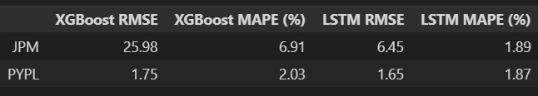
Lower RMSE and MAPE values indicate better prediction accuracy.

JPM: XGBoost Results
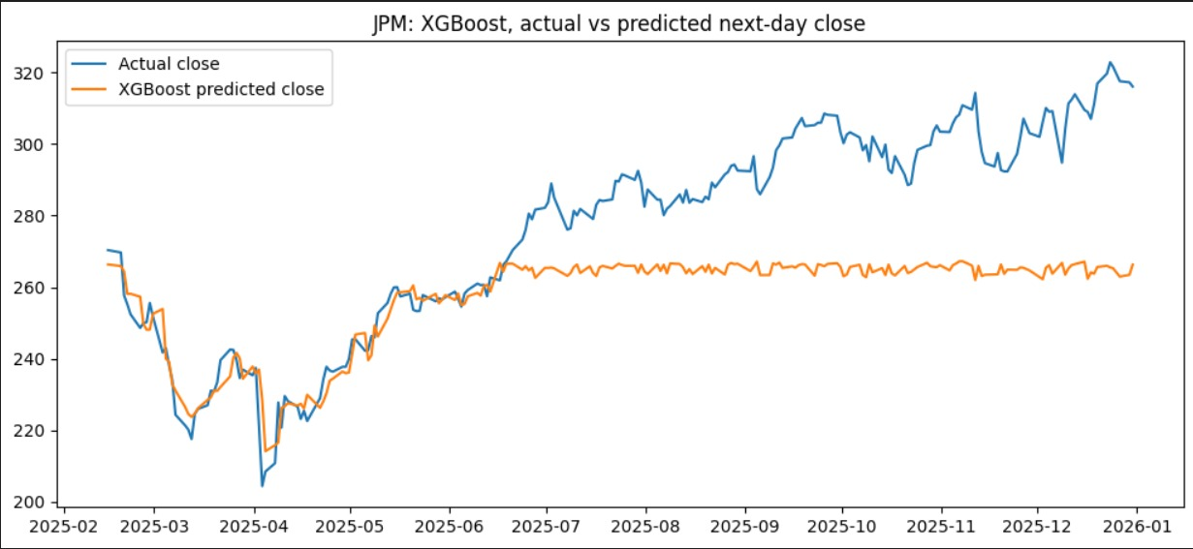
For JPM, the XGBoost model produced an RMSE of 25.98 and a MAPE of 6.91%.
The graph shows that the XGBoost predictions follow the actual JPM price reasonably well during the earlier portion of the test period. However, a major divergence develops from approximately June 2025 onwards.
The actual JPM price increases considerably and eventually moves above $300. In contrast, the XGBoost predicted price remains concentrated around approximately $265.
This indicates that the XGBoost model did not adequately capture the strong upward movement in JPM during the later part of the test period.
The relatively high RMSE of 25.98 supports the graphical observation that the model generated sizeable prediction errors.

JPM: LSTM Results
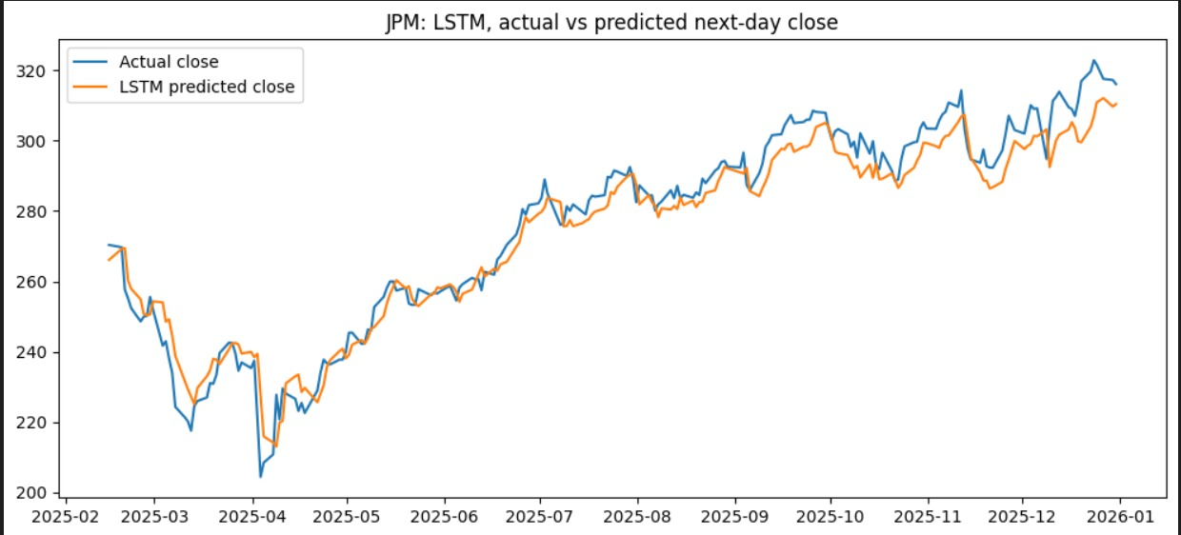
The LSTM model produced a much lower RMSE of 6.45 and MAPE of 1.89% for JPM.
The graph shows that the LSTM predicted series follows the actual JPM price much more closely than the XGBoost predictions.
The LSTM captures the major movements in the stock, including the decline during the early part of the test period, the subsequent recovery and the strong upward trend during the latter part of 2025.
Although the LSTM predictions do not perfectly reproduce every short-term movement, the overall trajectory is much closer to the actual series.
The reduction in RMSE from 25.98 to 6.45 and MAPE from 6.91% to 1.89% provides strong quantitative evidence that the LSTM model performed substantially better than XGBoost for JPM.

PYPL: XGBOOST RESULTS
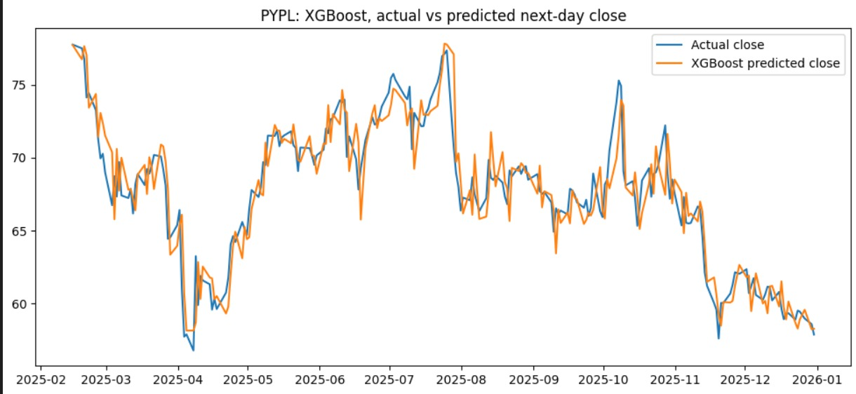
For PYPL, XGBoost produced an RMSE of 1.75 and a MAPE of 2.03%.
The predicted series generally follows the actual PYPL price throughout the test period. The model captures the major movements, including the decline during March–April 2025, the recovery during May–July, the decline around August and the subsequent fluctuations.
Compared with the JPM XGBoost results, the PYPL predictions are much closer to the actual values. This is reflected in the substantially lower RMSE and MAPE.
Therefore, XGBoost appears to have performed considerably better for PYPL than for JPM.

PYPL: LSTM RESULTS
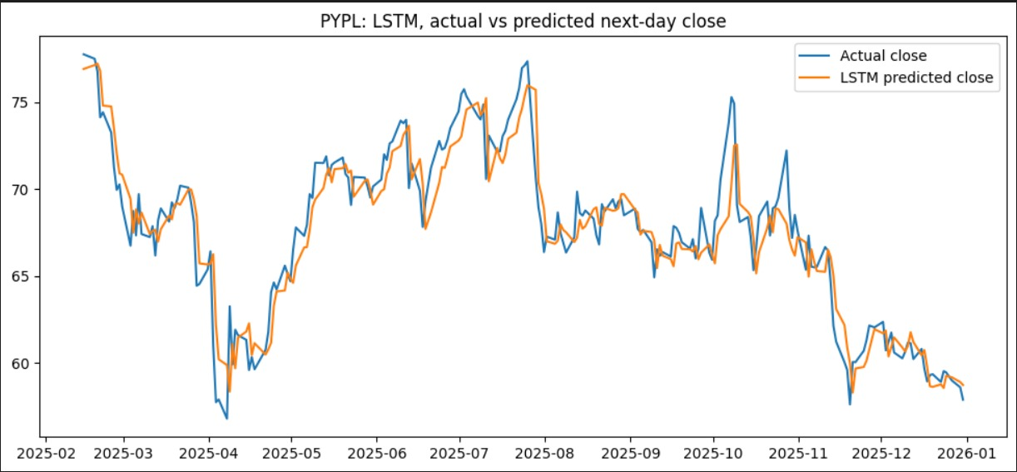
The LSTM model produced an RMSE of 1.65 and a MAPE of 1.87% for PYPL.
The graph shows that the predicted values track the actual PYPL price closely across most of the test period.
The model captures both upward and downward movements, although some deviations occur during periods of sharp price changes.
The LSTM therefore provides a slight improvement over XGBoost for PYPL, with RMSE declining from 1.75 to 1.65 and MAPE declining from 2.03% to 1.87%.

COMPARISON OF XGBOOST AND LSTM
The results clearly show that LSTM outperformed XGBoost for both JPM and PYPL.
For JPM:
- XGBoost RMSE = 25.98
- LSTM RMSE = 6.45
- XGBoost MAPE = 6.91%
- LSTM MAPE = 1.89%
The improvement is very substantial.
For PYPL:
- XGBoost RMSE = 1.75
- LSTM RMSE = 1.65
- XGBoost MAPE = 2.03%
- LSTM MAPE = 1.87%
Here, the improvement is smaller but still consistent across both measures.
The results suggest that LSTM was better able to capture the sequential and time-dependent patterns present in the stock-price data. This advantage was especially evident for JPM, where XGBoost failed to adapt to the strong upward movement during the second half of the test period.
Therefore, LSTM is the preferred forecasting model among the two models tested in this project.
However, the results should be interpreted as evidence of superior forecasting performance within the particular test period and model specification. They do not imply that LSTM will always outperform XGBoost or that the predicted prices are guaranteed to occur in the future.

Q1(iv): Backtesting of the Trading Strategy
Strategy Design
To evaluate whether XGBoost predictions can be converted into an effective investment strategy, a trading strategy was backtested using PayPal Holdings (PYPL), one of the securities selected for machine-learning analysis in Question 1(iii). The strategy used the XGBoost model's predicted closing price to generate daily trading signals.
The backtest was conducted from 18 February 2025 to 31 December 2025, with an initial capital of $100,000. In accordance with the assignment, $50,000 was allocated for trading, while the remaining $50,000 was treated as the margin reserve. The position-sizing logic limited the trading amount to a maximum of $50,000 and reduced the available amount if portfolio equity fell below the level required to maintain the reserve.
The XGBoost model was trained using historical daily price data available before the backtest period. Its input features included the closing price, one-day return, five-day return, five-day moving average, twenty-day moving average, percentage change in trading volume, trading volume, and Relative Strength Index (RSI-14).
Trading Rules
The strategy followed the rules specified in the assignment.
Long position: At the opening of the market, a long position was initiated if the predicted closing price was at least 0.5% higher than the previous trading day's closing price. The position was held until the market price reached at least 0.5% above the actual purchase price, at which point the position was liquidated.
Short position: A short position was initiated if the predicted closing price was at least 0.5% lower than the previous trading day's closing price. The short position was closed before the market closed on the same trading day.
Cash position: If neither condition was satisfied, the strategy remained in cash without opening a new position.
The algorithm used minute-level data to monitor price movements during the trading day and implemented its trading decisions shortly after the market opened.
Buy-and-Hold Benchmark
To assess the performance of the active trading strategy, a buy-and-hold benchmark was calculated using PYPL over the same evaluation period.
The first closing price of PYPL during the evaluation period was $77.75, while the last closing price was $57.87. The corresponding buy-and-hold return was calculated as follows:
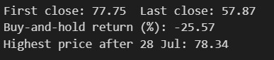
The resulting buy-and-hold return was approximately −25.57%.
The highest price observed after 28 July was $78.34.
Interpretation of Buy-and-Hold Performance
The buy-and-hold strategy generated a return of −25.57%, indicating that an investor who purchased PYPL at the beginning of the evaluation period and held the stock throughout the period would have experienced a substantial loss.
The decline from $77.75 to $57.87 indicates considerable weakness in PYPL during the evaluation period. Therefore, buy-and-hold provides a useful benchmark for assessing whether the active trading strategy achieved a better overall return.
Backtest Results of the Trading Strategy
The machine-learning-based trading strategy was evaluated using an initial capital of $100,000. The main results from the latest QuantConnect backtest are presented below.
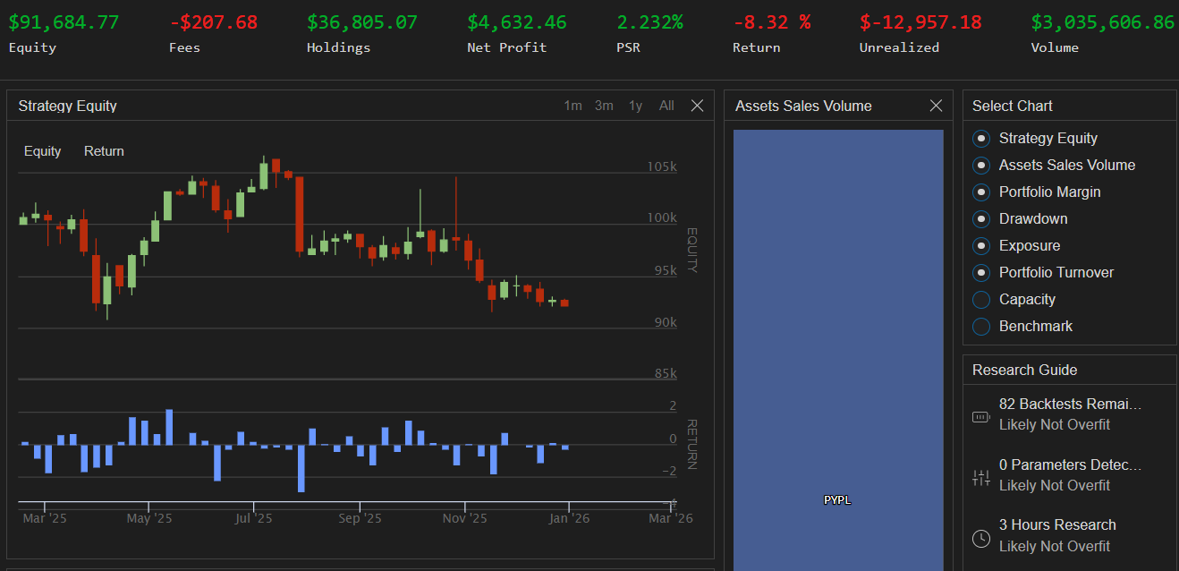
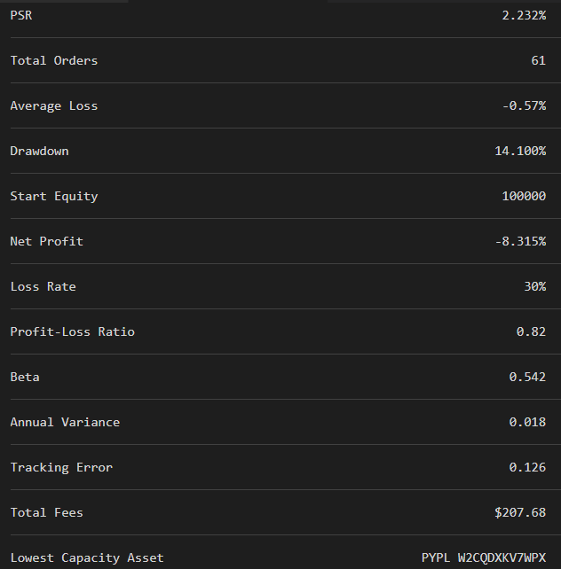
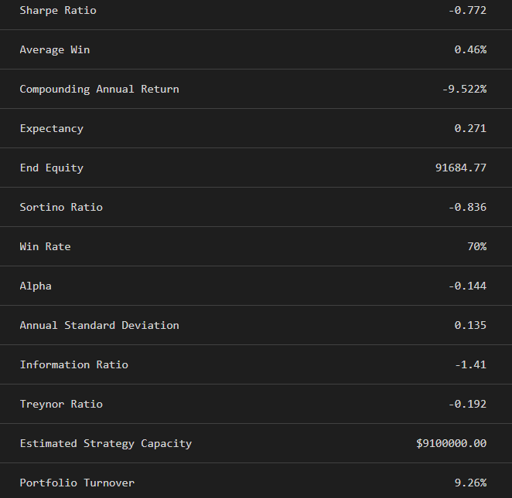
Figure 1: QuantConnect Backtest Dashboard, Equity Curve and overview of the XGBoost-Based PYPL Trading Strategy.
Interpretation of Backtest Results
The strategy started with an initial capital of $100,000 and ended with portfolio equity of $91,684.77. The overall portfolio return was −8.32%, indicating that the strategy generated a negative absolute return during the backtest period.
Nevertheless, the active trading strategy performed better than the buy-and-hold benchmark in terms of overall return. While buy-and-hold generated a return of −25.57%, the machine-learning-based strategy generated a return of −8.32%.
Thus, the strategy's overall return was 17.25 percentage points higher than the buy-and-hold return during the selected evaluation period. However, it did not generate a positive overall portfolio return.
Number of Trades and Win Rate
The strategy generated 61 orders during the backtest. The trade statistics reported 30 closed trades, of which 21 were profitable and 9 resulted in losses. This corresponded to a closed-trade win rate of 70% and a loss rate of 30%.
The average winning trade was 0.46%, whereas the average losing trade was −0.57%. Therefore, although profitable trades occurred more frequently, the average loss was larger than the average gain.
This relationship is reflected in the profit-loss ratio of 0.82. A ratio below 1 indicates that the average winning trade was smaller than the average losing trade in magnitude. Consequently, the relatively high win rate was not sufficient to ensure positive overall portfolio returns.
Maximum Drawdown
The maximum drawdown of the strategy was 14.10%. Maximum drawdown measures the largest decline in portfolio value from a previous peak to a subsequent trough during the backtest period.
A maximum drawdown of 14.10% indicates that the portfolio experienced a substantial peak-to-trough decline at some point during the evaluation period.
Although the strategy achieved a better overall return than buy-and-hold, the drawdown indicates that it was still exposed to meaningful downside risk. Therefore, the strategy cannot be considered low-risk solely because its overall loss was smaller than that of the benchmark.
Compounding Annual Return
The strategy recorded a compounding annual return of approximately −9.52%. This measure represents the annualised rate of return implied by the portfolio's performance over the evaluation period, accounting for compounding.
The negative value indicates that the strategy did not generate positive annualised growth during the backtest. Despite the relatively high percentage of profitable closed trades, the overall portfolio performance remained negative.
Sharpe Ratio
The strategy recorded a Sharpe ratio of approximately −0.772. The Sharpe ratio evaluates risk-adjusted performance by relating returns in excess of the risk-free rate to the variability of returns.
A negative Sharpe ratio indicates that the strategy did not generate a satisfactory return relative to the risk undertaken during the evaluation period. Therefore, despite its better performance relative to buy-and-hold, its risk-adjusted performance remained weak.
Sortino Ratio
The Sortino ratio was approximately −0.836. Unlike the Sharpe ratio, the Sortino ratio focuses on downside variability rather than total return variability.
The negative Sortino ratio indicates that the strategy did not adequately compensate investors for the downside risk experienced during the backtest. Together, the negative Sharpe and Sortino ratios indicate weak risk-adjusted performance.
Beta and Alpha
The strategy recorded a beta of approximately 0.542. A beta below 1 suggests lower estimated sensitivity to market movements than a portfolio with a beta of 1.
However, lower beta does not necessarily imply better overall performance, since the strategy still generated a negative portfolio return.
The strategy's alpha was approximately −0.144. The negative alpha indicates unfavourable estimated excess performance relative to the benchmark relationship used in the backtest statistics. Thus, the strategy did not generate positive alpha over the selected period.
Annual Standard Deviation and Variance
The annual standard deviation was approximately 0.135, or 13.5%, while the annual variance was approximately 0.018.
Standard deviation measures the variability of returns around their mean, whereas variance is the square of standard deviation. These measures indicate that the strategy experienced fluctuations in portfolio returns during the evaluation period.
Although the strategy's overall loss was smaller than the buy-and-hold loss, the risk measures show that it continued to experience meaningful return variability.
Information Ratio and Treynor Ratio
The Information Ratio was approximately −1.41. This measure evaluates benchmark-relative performance in relation to tracking error. Its negative value indicates unfavourable benchmark-relative performance during the evaluation period.
The Treynor ratio was approximately −0.192. It relates excess return to estimated systematic risk, measured using beta. The negative Treynor ratio indicates that the strategy did not provide positive excess returns per unit of estimated systematic risk.
Together, these measures reinforce the conclusion that the strategy did not achieve satisfactory risk-adjusted performance.
Trading Costs and Portfolio Turnover
The strategy incurred total trading fees of $207.68, and the reported portfolio turnover was approximately 9.26%. The 61 orders indicate that the algorithm involved active trading rather than a passive buy-and-hold approach.
Transaction costs reduce the returns generated by trading activity and must therefore be considered when evaluating the practical effectiveness of a strategy. In this case, the overall negative portfolio return indicates that the strategy did not produce positive net portfolio growth over the evaluation period.
Open Position and Unrealized Loss
An important feature of the final backtest was that a long position remained open at the end of the evaluation period. The position had not reached the prescribed profit-taking threshold of 0.5% above the actual purchase price and therefore remained in the portfolio.
The QuantConnect dashboard reported an unrealized loss of $12,957.18 at the end of the backtest. This loss substantially affected the final portfolio value.
The dashboard also reported $4,632.46 as Net Profit. This figure should not be interpreted as the overall change in portfolio equity. The final portfolio equity was $91,684.77, representing a decrease of $8,315.23 from the initial capital of $100,000.
The dashboard metrics and overall portfolio equity capture different aspects of the strategy's performance. The remaining holdings had an unrealized loss, so profitable completed trades did not necessarily translate into a profitable total portfolio.
Comparison of Trading Strategy with Buy-and-Hold
Table 2: Comparison of Investment Performance
Strategy | Return
PYPL Buy-and-Hold | −25.57%
Machine-learning trading strategy | −8.32%
Improvement relative to Buy-and-Hold | 17.25 percentage points
The machine-learning-based trading strategy outperformed the buy-and-hold benchmark in terms of overall portfolio return during the selected evaluation period. Although both strategies generated negative returns, the loss associated with the active trading strategy was substantially smaller.
The buy-and-hold strategy generated a return of −25.57%, compared with −8.32% for the machine-learning-based strategy. Therefore, the active strategy delivered a 17.25-percentage-point improvement in return relative to buy-and-hold.
However, the strategy should not be considered completely successful because it did not generate a positive absolute return. Its negative Sharpe ratio, Sortino ratio, alpha, Information Ratio and Treynor ratio indicate weak risk-adjusted performance. In addition, the strategy ended the evaluation period with a long position carrying a substantial unrealized loss.
Conclusion of Q1(iv)
The backtesting results provide mixed evidence regarding the effectiveness of the XGBoost-based trading strategy. The strategy outperformed the buy-and-hold benchmark in terms of overall portfolio return, reducing the loss from 25.57% to 8.32%, an improvement of 17.25 percentage points.
The strategy recorded a 70% win rate among its 30 closed trades. However, its overall portfolio return remained negative, with a final portfolio value of $91,684.77 and a compounding annual return of approximately −9.52%. Its maximum drawdown of 14.10%, negative Sharpe ratio of −0.772, and negative Sortino ratio of −0.836 also indicate weak risk-adjusted performance.
The presence of an open long position with an unrealized loss of $12,957.18 substantially affected the final result. This demonstrates that the percentage of profitable closed trades alone is not sufficient to assess a trading strategy's effectiveness; the size of losses, duration of open positions, unrealized performance and transaction costs must also be considered.
Overall, the XGBoost-based trading strategy was more effective than buy-and-hold in limiting losses during the selected backtest period. Nevertheless, it was not profitable in absolute terms and did not generate satisfactory risk-adjusted returns. These findings apply to the selected evaluation period and do not guarantee future performance.

QUESTION 2: BUILDING A PORTFOLIO THAT BALANCES RISK AND RETURN
Q 2(i) Equal-Weight Portfolio
An equal-weight portfolio was constructed by allocating an equal proportion of capital to each of the ten securities.
Since ten securities are included, each security receives an equal portfolio weight of approximately 10%.
The purpose of the equal-weight portfolio is to create a diversified portfolio without giving preference to any individual security.
The portfolio was compared with the NYSE Composite Index (NYA) as a broad market benchmark.
DAILY RETURNS: EQUAL-WEIGHT PORTFOLIO VS NYSE COMPOSITE
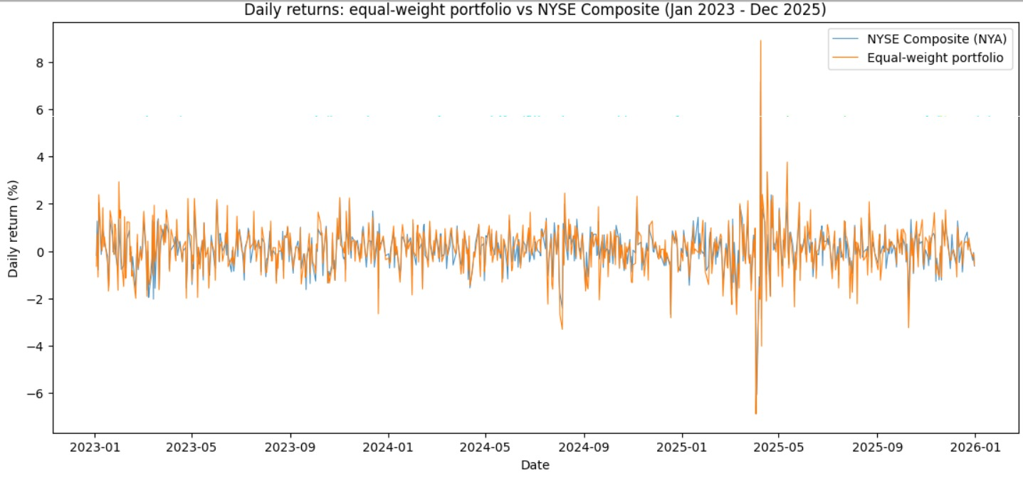
The graph shows that the equal-weight portfolio and the NYSE Composite generally fluctuate around zero and experience both positive and negative daily returns.
However, the equal-weight portfolio displays somewhat larger short-term fluctuations at certain points in the sample period.
The particularly large movements around early 2025 indicate a period of increased market volatility.
Despite these fluctuations, diversification across ten securities prevents the portfolio from being completely dependent on the performance of any single security.
This is one of the main advantages of portfolio diversification.
GROWTH OF $100: EQUAL-WEIGHT PORTFOLIO VS NYSE COMPOSITE
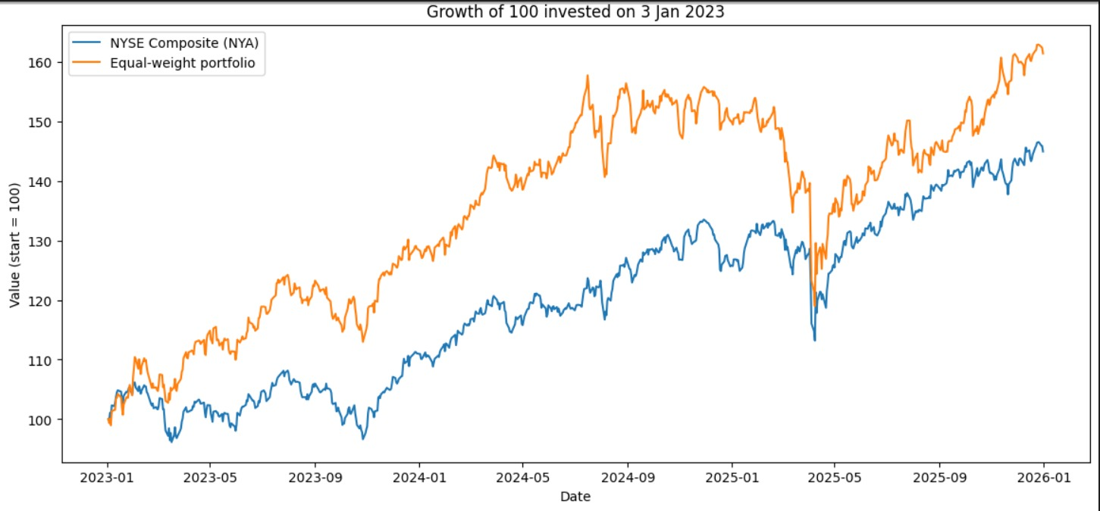
The growth-of-$100 graph shows the cumulative performance of the equal-weight portfolio compared with the NYSE Composite.
An initial investment of $100 in the equal-weight portfolio increased to approximately $161–162 by the end of the sample period.
The backtest provides the exact ending equity for a $100,000 initial investment as $161,361.95, corresponding to a total return of 61.36%.
The NYSE Composite ended at approximately $145–146 according to the graph.
Therefore, the equal-weight portfolio appears to have outperformed the NYSE Composite over the sample period.
This suggests that an equally diversified portfolio of the selected securities generated stronger cumulative performance than the broad market benchmark during this particular period.

EQUAL-WEIGHT PORTFOLIO BACKTEST RESULTS
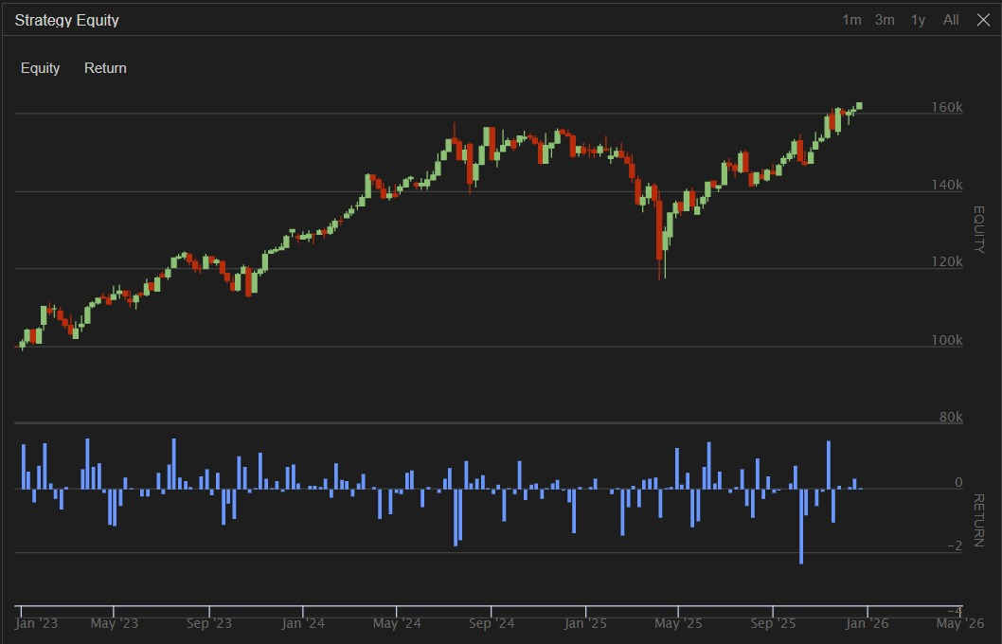
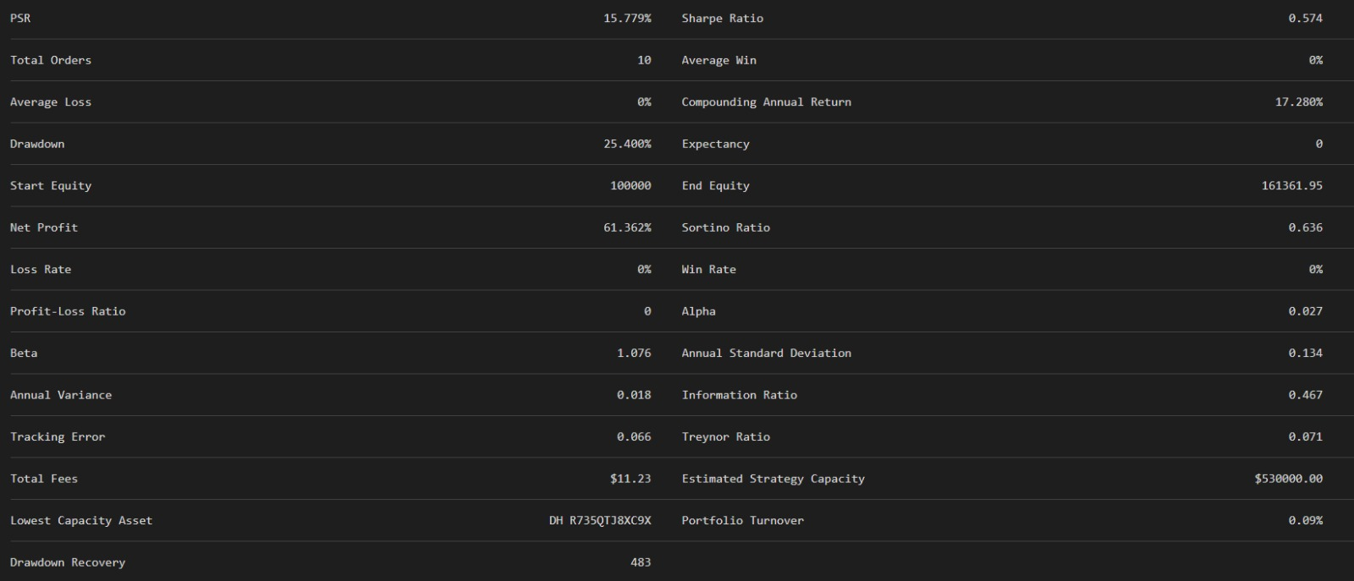
The equal-weight portfolio started with $100,000 and ended with $161,361.95.
The resulting net profit was approximately:
$61,361.95
and the total return was:
61.36%
The portfolio's compounded annual return was 17.28%.
This represents a strong cumulative performance over the three-year period.

Sharpe Ratio
The equal-weight portfolio recorded a Sharpe ratio of 0.574.
The positive Sharpe ratio indicates that the portfolio generated positive risk-adjusted performance during the backtest period.
However, the value is below 1, suggesting that the risk-adjusted return was moderate rather than exceptionally high.

Sortino Ratio
The portfolio's Sortino ratio was 0.636.
The Sortino ratio focuses more specifically on downside risk rather than total volatility.
The positive value indicates that the portfolio generated positive returns relative to its downside risk during the backtest period.

Maximum Drawdown
The equal-weight portfolio recorded a maximum drawdown of 25.40%.
Therefore, although the portfolio generated a 61.36% cumulative return, investors would have experienced a substantial temporary decline during the period.
This demonstrates that diversification reduces certain forms of risk but does not eliminate market risk.

Beta and Volatility
The equal-weight portfolio had a beta of 1.076.
A beta slightly above one indicates that the portfolio was somewhat more sensitive to broad market movements than the benchmark.
Its annual standard deviation was 13.5%, indicating the variability of its annualized returns.
The portfolio's annual variance was 0.018.

Trading Activity and Costs
The equal-weight portfolio recorded only 10 total orders and portfolio turnover of 0.09%.
This indicates relatively low trading activity.
The total fees were only $11.23, meaning transaction costs had a very limited impact on overall performance.
This is an important advantage of the equal-weight strategy compared with a more actively rebalanced optimized strategy.

Q 2(ii). OPTIMIZED PORTFOLIO PERFORMANCE
Portfolio Optimization Methodology and Monthly Weight Allocation
The optimized portfolio was constructed using Markowitz mean-variance optimization, with the objective of maximizing the Sharpe ratio. The portfolio weights were recalculated at the beginning of each month using historical daily returns and the corresponding covariance matrix. A risk-free rate of 4% was assumed.

The optimization was subject to two main constraints: the weights of all ten securities had to sum to 100%, and every security had to receive a minimum target allocation of 5%. The portfolio maintained long-only positions and was rebalanced monthly. During the initial months, when fewer than the required 60 historical observations were available, the strategy temporarily used equal weights. Once sufficient data became available, the optimizer determined the target allocation based on the estimated risk-return characteristics of the securities.

Table: Selected Monthly Target Portfolio Weights (%)
Security | Apr 2023 | Oct 2023 | Apr 2024 | Oct 2024 | Apr 2025 | Dec 2025
AAPL | 50.7% | 6.0% | 5.0% | 11.4% | 38.4% | 5.0%
MSFT | 5.0% | 5.0% | 9.2% | 12.9% | 5.0% | 5.0%
JPM | 5.0% | 5.0% | 25.5% | 23.4% | 21.6% | 9.2%
LLY | 5.0% | 29.8% | 30.3% | 19.4% | 5.0% | 50.8%
TGT | 5.0% | 5.0% | 5.0% | 7.6% | 5.0% | 5.0%
AOS | 5.0% | 5.0% | 5.0% | 5.3% | 5.0% | 5.0%
NOG | 5.0% | 7.9% | 5.0% | 5.0% | 5.0% | 5.0%
POR | 5.0% | 5.0% | 5.0% | 5.0% | 5.0% | 5.0%
FDX | 9.3% | 26.3% | 5.0% | 5.0% | 5.0% | 5.0%
PYPL | 5.0% | 5.0% | 5.0% | 5.0% | 5.0% | 5.0%

Source: Monthly target-weight allocations recorded in the QuantConnect backtest logs.
The table illustrates how portfolio allocations changed over time. For example, AAPL received a target weight of 50.7% in April 2023, whereas LLY received a target weight of 50.8% in December 2025. This variation reflects changes in the estimated returns and risk characteristics used by the optimizer. The minimum 5% target allocation ensured that every security remained represented in the portfolio, while the remaining capital was allocated according to the optimization results.

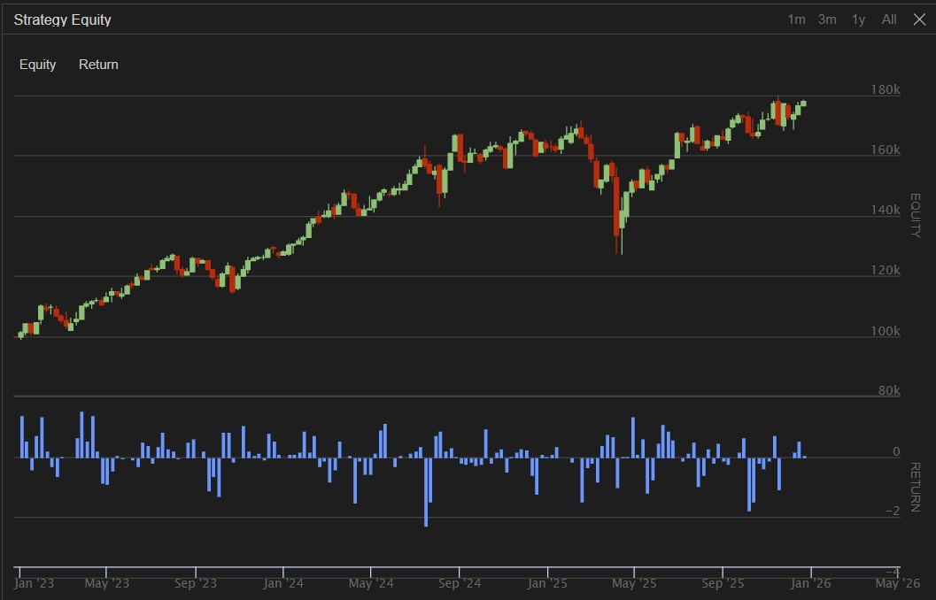
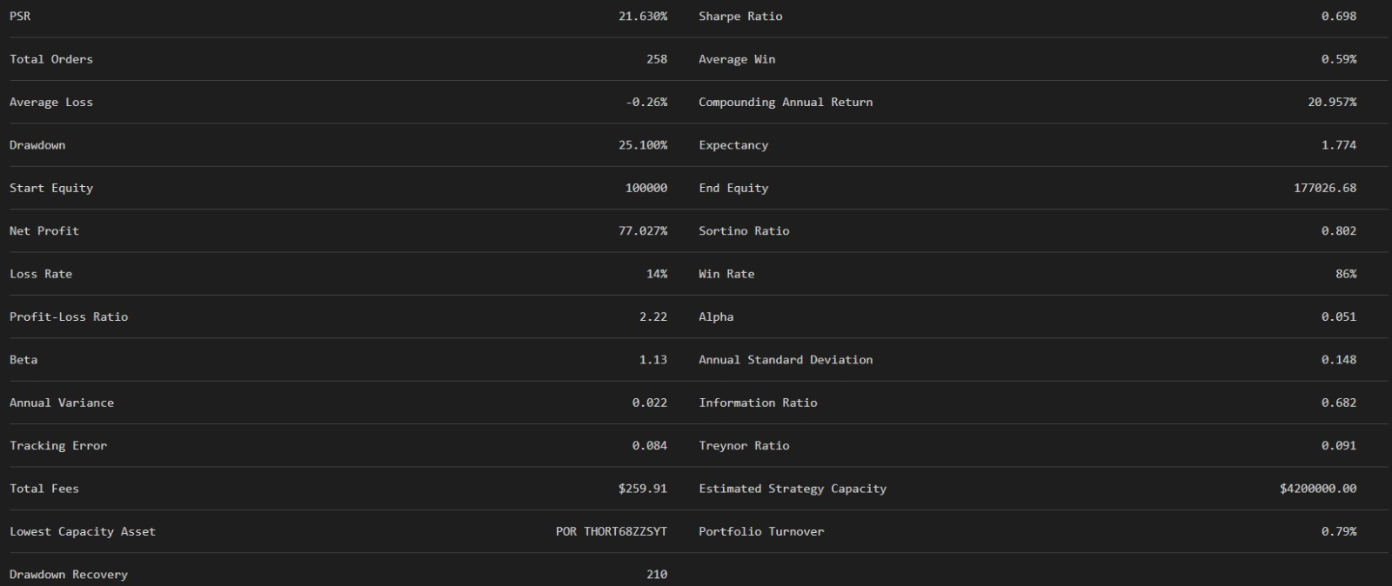
Interpretation of the Optimized Portfolio Backtest
The optimized portfolio started with an initial capital of $100,000 and ended with an equity value of $177,026.68. This represents a total return of approximately 77.03%, with a net profit of $77,026.68.
The compounded annual return was 20.957%, indicating that the portfolio generated an annualized compounded return of approximately 20.96% over the backtest period.
The positive total return indicates that the optimized portfolio was able to generate substantial growth in portfolio value during the sample period.
Risk-Adjusted Performance
The optimized portfolio recorded a Sharpe ratio of 0.698. The positive Sharpe ratio indicates that the portfolio generated positive returns relative to the total risk undertaken.
The Sortino ratio was 0.802, which evaluates performance relative to downside risk. The positive Sortino ratio indicates that the portfolio generated positive returns relative to its downside risk.
The portfolio therefore demonstrated reasonably favourable risk-adjusted performance during the backtest period.
Drawdown and Volatility
The maximum drawdown was 25.10%. This represents the largest peak-to-trough decline experienced by the portfolio during the backtest.
Although the portfolio experienced a substantial temporary decline, it subsequently recovered and ended the period with a strong positive return.
The annual standard deviation was 14.8%, indicating the degree of variability in the portfolio's returns. The annual variance was 0.022.
Trading Performance
The optimized portfolio recorded a win rate of 86% and a loss rate of 14%.
The average winning trade was 0.59%, whereas the average losing trade was −0.26%. Thus, the average winning trade was larger in magnitude than the average losing trade.
This is reflected in the profit-loss ratio of 2.22, which indicates a favourable relationship between average gains and average losses.
The reported expectancy was 1.774, indicating positive expected performance based on the historical trading outcomes of the strategy.
Market Risk
The optimized portfolio had a beta of 1.13, indicating that it was somewhat more sensitive to market movements than a portfolio with a beta of 1.
The portfolio also recorded a positive alpha of 0.051, suggesting positive excess performance relative to what would be expected from its systematic market exposure.
The Information Ratio of 0.682 and Treynor Ratio of 0.091 were also positive, providing further evidence of favourable risk-adjusted performance during the backtest period.
Trading Costs
The optimized portfolio executed 258 orders and incurred total fees of $259.91.
The portfolio turnover was 0.79%. The higher number of orders indicates that the optimized portfolio involved substantially more active trading than the equal-weight portfolio.
Therefore, transaction costs should be considered when evaluating whether the backtested performance can be replicated in actual investment conditions.

Comparison with the Equally Weighted Portfolio
The optimized portfolio was compared with the equally weighted portfolio using the backtest results.
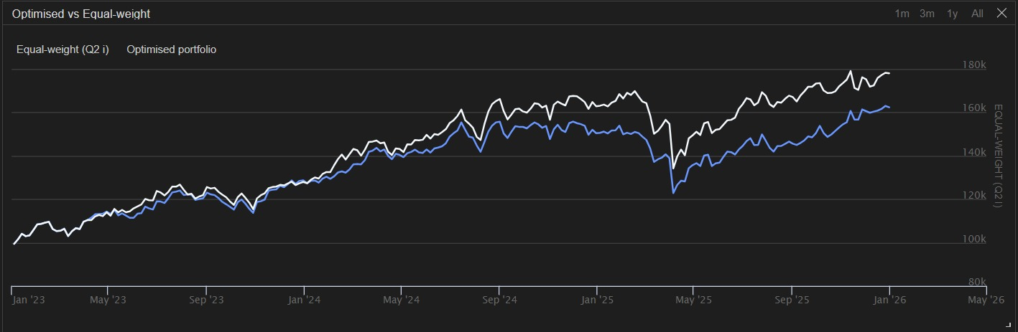
The graph shows that both portfolios increased in value over the sample period. However, the optimized portfolio remained above the equally weighted portfolio for a substantial part of the later period and finished at a higher portfolio value.
The numerical comparison is presented below.
Table 2: Optimized Portfolio vs Equal-Weight Portfolio
Measure | Equal-Weight Portfolio | Optimized Portfolio
Initial Capital | $100,000 | $100,000
Ending Equity | $161,361.95 | $177,026.68
Total Return | 61.36% | 77.03%
Net Profit | $61,361.95 | $77,026.68
Compounding Annual Return | 17.28% | 20.96%
Sharpe Ratio | 0.574 | 0.698
Sortino Ratio | 0.636 | 0.802
Maximum Drawdown | 25.40% | 25.10%
Annual Standard Deviation | 13.4%* | 14.8%
Beta | 1.076 | 1.13
Information Ratio | 0.467 | 0.682
Treynor Ratio | 0.071 | 0.091
Total Orders | 10 | 258
Total Fees | $11.23 | $259.91
Portfolio Turnover | 0.09% | 0.79%
*The backtest screenshot reports annual standard deviation for the equal-weight portfolio as approximately 0.134, i.e. 13.4%. Use the exact displayed value if your original output shows more decimal places.

Comparison of Returns
The equally weighted portfolio generated a total return of 61.36%, while the optimized portfolio generated a total return of 77.03%.
Therefore, the optimized portfolio outperformed the equally weighted portfolio by:
77.03% − 61.36% = 15.67 percentage points.
In terms of ending wealth, an initial investment of $100,000 grew to $161,361.95 under the equal-weight strategy and to $177,026.68 under the optimized strategy.
Thus, the optimized portfolio generated approximately $15,664.73 more ending wealth than the equal-weight portfolio.

Comparison of Annualized Returns
The equal-weight portfolio recorded a compounded annual return of 17.28%, while the optimized portfolio recorded 20.96%.
Therefore, the optimized portfolio generated approximately 3.68 percentage points higher compounded annual return.
This indicates that the optimized portfolio achieved stronger annualized growth over the backtest period.

Comparison of Sharpe Ratio
The equal-weight portfolio had a Sharpe ratio of 0.574, while the optimized portfolio had a Sharpe ratio of 0.698.
Since a higher Sharpe ratio indicates better return relative to total risk, the optimized portfolio performed better on a risk-adjusted basis according to the Sharpe ratio.

Comparison of Sortino Ratio
The equal-weight portfolio recorded a Sortino ratio of 0.636, compared with 0.802 for the optimized portfolio.
The higher Sortino ratio of the optimized portfolio indicates better returns relative to downside risk.
Therefore, the optimized portfolio also performed better when downside risk is considered specifically.

Comparison of Maximum Drawdown
The equal-weight portfolio had a maximum drawdown of 25.40%, whereas the optimized portfolio had a maximum drawdown of 25.10%.
Thus, the optimized portfolio had a slightly lower maximum drawdown by approximately 0.30 percentage points.
This is particularly important because the optimized portfolio achieved a substantially higher return without experiencing a materially larger maximum drawdown.

Comparison of Volatility
The optimized portfolio had annual standard deviation of approximately 14.8%, compared with approximately 13.4% for the equal-weight portfolio.
Therefore, the optimized portfolio experienced somewhat higher return volatility.
This indicates that the higher return of the optimized portfolio came with a modest increase in overall volatility.

Comparison of Beta
The beta of the equal-weight portfolio was 1.076, while the optimized portfolio had a beta of 1.13.
Both portfolios therefore had beta values slightly above one, indicating sensitivity to broader market movements.
The optimized portfolio had slightly higher systematic market exposure than the equal-weight portfolio.

Comparison of Information Ratio and Treynor Ratio
The optimized portfolio had an Information Ratio of 0.682, compared with 0.467 for the equal-weight portfolio.
Similarly, the optimized portfolio had a Treynor Ratio of 0.091, compared with 0.071 for the equal-weight portfolio.
Both measures therefore favour the optimized portfolio, indicating better active performance and better return relative to systematic risk.

Comparison of Trading Activity and Costs
The equal-weight portfolio required only 10 orders and incurred fees of $11.23.
In comparison, the optimized portfolio executed 258 orders and incurred fees of $259.91.
Therefore, the optimized portfolio was substantially more active and more expensive to implement.
This is an important limitation because backtested returns may be affected by transaction costs, bid-ask spreads, taxes and other real-world implementation costs that may not be fully captured in the backtest.

Conclusion of Q2(ii)
The optimized portfolio performed better than the equally weighted portfolio on the major return and risk-adjusted performance measures.
The optimized portfolio generated a 77.03% total return, compared with 61.36% for the equally weighted portfolio. It also recorded a higher compounded annual return, Sharpe ratio, Sortino ratio, Information Ratio and Treynor Ratio.
At the same time, its maximum drawdown was 25.10%, slightly lower than the 25.40% drawdown of the equal-weight portfolio.
However, the optimized portfolio had somewhat higher volatility and beta and involved considerably more trading activity. It also incurred higher transaction costs.
Overall, the backtest suggests that the optimization technique was able to improve the portfolio's historical return and risk-adjusted performance relative to equal weighting.

Q2(iii) Portfolio Selection and Suggestions for Improvement
Portfolio Selection
Based on the backtest results obtained in Q2(ii), I would choose the optimized portfolio over the equally weighted portfolio.
The main reason is that the optimized portfolio generated a substantially higher return while also showing better risk-adjusted performance.
The optimized portfolio generated a total return of 77.03%, compared with 61.36% for the equal-weight portfolio. Therefore, the optimized portfolio outperformed the equal-weight portfolio by 15.67 percentage points.
The optimized portfolio also had a higher Sharpe ratio (0.698 compared with 0.574) and a higher Sortino ratio (0.802 compared with 0.636). These results indicate better risk-adjusted performance and better performance relative to downside risk.
Furthermore, the maximum drawdown was slightly lower for the optimized portfolio (25.10%) than for the equal-weight portfolio (25.40%).
Therefore, considering return, risk-adjusted performance and drawdown together, the optimized portfolio is the preferable choice based on the historical backtest.
However, this conclusion should be interpreted with caution because past backtest performance does not guarantee future performance.

Suggestions for Further Improvement
1. Include Transaction Costs and Market Frictions
The optimized portfolio executed 258 orders and incurred $259.91 in fees, compared with only 10 orders and $11.23 fees for the equal-weight portfolio.
Future versions of the strategy should incorporate realistic transaction costs, bid-ask spreads, slippage and taxes wherever applicable. This would provide a more realistic estimate of the portfolio's performance.

2. Reduce Excessive Trading
The optimized portfolio involves considerably more trading than the equal-weight portfolio.
A minimum change threshold could be introduced so that the portfolio is rebalanced only when the desired weight differs from the existing weight by a specified amount. This could reduce unnecessary transactions and lower trading costs.
3. Add Risk Constraints
Although the optimized portfolio performed well, its maximum drawdown was still 25.10%.
Additional constraints could be introduced to control portfolio risk, such as maximum individual-stock weights, volatility constraints or maximum portfolio drawdown limits.
4. Use More Robust Optimization
The portfolio weights may be sensitive to the historical sample used for optimization. More robust techniques such as mean-variance optimization with regularization, risk-parity approaches or minimum-variance optimization could be considered.
These methods may help reduce the possibility of overfitting the portfolio to historical data.
5. Perform Out-of-Sample Testing
The optimization should ideally be performed using historical training data, while portfolio performance should be evaluated on a separate out-of-sample period.
This would help determine whether the strategy genuinely generalizes to unseen data rather than simply fitting the historical sample.
6. Consider Rolling or Walk-Forward Optimization
Instead of relying on a single set of portfolio weights, the optimization process could be repeated using a rolling historical window.
This would allow the portfolio to adapt to changing market conditions while still maintaining a disciplined methodology.
7. Maintain Diversification
The minimum 5% allocation constraint ensures that every stock is included in the portfolio. However, the optimized portfolio should also be monitored for excessive concentration in particular stocks or sectors.
Additional maximum-weight constraints could be introduced to prevent the portfolio from becoming excessively concentrated.

Final Conclusion for Q2(iii)
Overall, I would select the optimized portfolio because it produced a higher total return of 77.03% compared with 61.36% for the equal-weight portfolio, while also achieving higher Sharpe and Sortino ratios and a slightly lower maximum drawdown.
The optimized portfolio therefore provided a better historical risk-return trade-off during the backtest period.
However, the optimized portfolio required substantially more trading and incurred higher transaction costs. It also had slightly higher volatility and beta. Therefore, before implementing the strategy in practice, I would recommend incorporating realistic transaction costs, reducing unnecessary rebalancing, imposing additional risk and concentration constraints, and conducting out-of-sample or walk-forward testing.
Hence, the optimized portfolio is preferred based on the backtest results, but further robustness testing and realistic implementation assumptions are necessary before considering it suitable for actual investment.

